2020 U.S. Biathlon Team Talent ID Camp  June 14-18, 2020 - LAKE PLACID, NY | 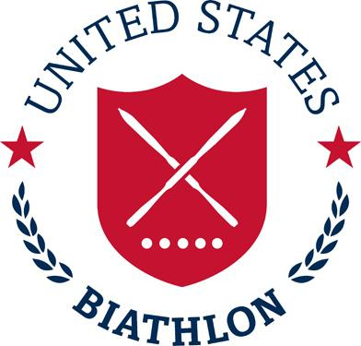
Application

Please send completed application as an attachment or directly in an email to tburke@usbiathlon.org by April 1, 2020 at 11:59pm EST.

Personal Information
Name:
Address:
Date of Birth:
Email:
Cell phone:
Parents names and cell phone (for emergency contact):

Sport and Physical Background
Ski/Biathlon Club/School/College:
Coach’s name, email and phone (optional):
High School and/or College Graduation Dates:
Current Year in college (if applicable):

Right or Left handed:
Height:
Weight:
Do you have access to a biathlon rifle (not required):

- List several of your best cross-country skiing results from the past two seasons (Cross Country National Champs, JNs, regional JNQs, State HS Champs, College Races, NCAA Champs, USSA Points, FIS Points):

- What other sports do you compete in?

- Please list some of your top results (times and distances) from the past two years:

- Have you had any laboratory testing: lactate profile or max VO2? If so, please include results:

- What were your training hours last year?
- What are your current overall goals in sport?

- Why are you interested in Biathlon?

